¿Qué es eRegistrations?
eRegistrations es una plataforma de desarrollo de código bajo que permite desarrollar aplicaciones de gobierno electrónico, a través de las cuales los usuarios del servicio público pueden solicitar registros en línea simultáneamente con varias instituciones gubernamentales, utilizando un solo formulario, un solo conjunto de documentos y un solo pago.

- Los analistas pueden configurar servicios en línea sin necesidad de programar (en un módulo llamado Business Process Analyzer) y, una vez listos, publicarlos en la parte pública del sistema (llamada Display System).
- Los usuarios pueden solicitar los servicios en línea a través de una aplicación pública.

Architecture of eRegistrations is microservices

Microservices architecture is an approach to software development where a complex application is broken down into smaller, loosely coupled services. Each service is responsible for a specific business capability and can be developed, deployed, and scaled independently. This architectural style promotes flexibility, scalability, and resilience.

Principles of Microservices Architecture
- Single Responsibility: Each microservice should focus on performing a single business function, adhering to the Single Responsibility Principle (SRP).
- Loose Coupling: Services should be decoupled from each other, allowing them to evolve independently without affecting the entire system.
- Autonomy: Microservices should be independently deployable and scalable, enabling teams to work autonomously and release updates frequently.
- Resilience: Failures in one service should not cascade to other services. Each service should be resilient to failures and degrade gracefully when necessary.
- Polyglot Persistence: Different services can use different databases or data storage technologies based on their specific requirements.

Components of Microservices Information System

Service Components
- User Service: Responsible for managing user authentication, authorization, and profile information. In eRegistrations we have Keycloak for authentication, Display for public users, Business Process Analyzer for admin users and many smaller user interfaces for configuration and maintenance (e.g. Graylog for log management).

- Catalog Service: Handles product catalog management, including CRUD operations for products, categories, and attributes. eRegistrations uses Restheart to store translations and other catalogs, Generic Database to store any other registry information.

- Order Service: Manages the order lifecycle, including order creation, payment processing, and order fulfillment. eRegistration uses battle tested Camunda workflow management.

- Inventory Service: Tracks inventory levels and manages stock for products.
- Notification Service: Sends notifications to users regarding order status updates, promotions, and other relevant information.
- Analytics Service: Collects and analyzes data from various sources to provide insights into user behavior, product performance, and business trends.

Infrastructure Components

- API Gateway: Acts as a single entry point for client requests, routing them to the appropriate microservice and handling cross-cutting concerns such as authentication, rate limiting, and logging.
- Service Registry: Maintains a registry of available services and their network locations, enabling dynamic service discovery and load balancing.
- Event Bus: Facilitates communication between microservices through asynchronous messaging, allowing for loose coupling and scalability.
- Monitoring and Logging: Monitors the health and performance of microservices, collects logs for troubleshooting and analysis, and generates alerts for abnormal behavior.

Benefits of Microservices Information System

- Scalability: Microservices can be independently scaled based on demand, allowing for efficient resource utilization and cost optimization.
- Flexibility: Teams can choose the most suitable technology stack for each microservice, enabling innovation and rapid development.
- Fault Isolation: Failures in one microservice do not affect the entire system, enhancing resilience and fault tolerance.
- Continuous Deployment: Independent deployment of microservices enables continuous delivery of new features and updates, reducing time-to-market.
- Improved Maintainability: Smaller codebases and clear service boundaries make it easier to understand, maintain, and evolve the system over time.

The Microservices Information System architecture offers a modern and scalable approach to building complex software systems. By decomposing applications into smaller, manageable services, organizations can achieve greater agility, scalability, and resilience, ultimately delivering better experiences for users and stakeholders.

Principles of eRegistrations is NO-CODE

In this chapter, we explore the fundamental principles that underpin the philosophy and practice of eRegistrations no-code software development. No-code development empowers users to create functional software applications without writing traditional code, democratizing the process of building digital solutions.

Gartner no-code/low code market predictions
In terms of what’s in store for low code app development platforms, Gartner’s “Magic Quadrant for Enterprise Low-Code Application Platforms” report found “By 2024, three-quarters of large enterprises will be using at least four rapid application development tools for both IT application development and citizen development initiatives…By 2024, low-code application development will be responsible for more than 65% of application development activity.”

Accessibility and Empowerment
No-code platforms aim to make software development accessible to a broader audience, including business users, domain experts, and non-technical professionals. By abstracting away the complexities of coding, these platforms empower individuals with diverse backgrounds and skill sets to create their own custom applications, reducing reliance on specialized developers and IT departments.

Visual Development Paradigm
At the heart of no-code development is the visual development paradigm, where users design and configure applications using intuitive graphical interfaces rather than writing lines of code. Drag-and-drop editors, visual workflows, and declarative rules engines enable users to assemble components, define logic, and specify behaviors through visual representations, fostering rapid prototyping and iterative refinement.

Abstraction of Technical Complexity
No-code platforms abstract away much of the technical complexity involved in software development, allowing users to focus on solving business problems and implementing functional requirements without getting bogged down in implementation details. By encapsulating common patterns, best practices, and reusable components, these platforms enable users to build sophisticated applications without needing to understand the underlying intricacies of programming languages or frameworks.

Modularity and Reusability
No-code development encourages the creation of modular, reusable components that can be easily shared, combined, and extended across different projects and applications. By promoting a component-based architecture, users can leverage pre-built templates, widgets, and integrations to accelerate development, foster collaboration, and maintain consistency across their applications.

Rapid Iteration and Experimentation
No-code development fosters a culture of rapid iteration and experimentation, enabling users to quickly build, test, and refine their ideas without significant time or resource investment. With instant feedback loops and real-time previews, users can iterate on their designs, gather user feedback, and make iterative improvements to their applications, accelerating the innovation cycle and reducing time-to-market.

Flexibility and Extensibility
While no-code platforms provide a rich set of out-of-the-box capabilities, they also offer flexibility and extensibility to accommodate a wide range of use cases and requirements. Through custom scripting, API integrations, and extensibility mechanisms, users can extend the functionality of their applications, integrate with external services, and tailor their solutions to meet specific needs or constraints.

Alignment with Business Objectives
No-code development aligns closely with business objectives by prioritizing the delivery of tangible outcomes and business value. By enabling business users to directly participate in the development process, no-code platforms bridge the gap between IT and the business, fostering collaboration, innovation, and alignment with strategic goals and objectives.

Continuous Improvement and Learning
No-code development encourages continuous improvement and learning by providing opportunities for users to experiment, iterate, and expand their skills and knowledge over time. Through hands-on experience, community engagement, and access to educational resources, users can deepen their understanding of software development concepts and practices, empowering them to tackle increasingly complex challenges and drive innovation within their organizations.

The principles of no-code software development represent a paradigm shift in how software is created, democratizing access to technology and empowering individuals to become creators rather than consumers of digital solutions. By embracing accessibility, visual development, abstraction, modularity, and flexibility, no-code platforms enable users to build, iterate, and innovate faster than ever before, ushering in a new era of creativity, collaboration, and empowerment in the world of software development.

Stack de tecnologías
Los microservicios de eRegistrations han sido creados utilizando una variedad de tecnologías que han sido cuidadosamente elegidas para que coincidan con los requisitos de cada sistema individual. Las tecnologías actuales son las siguientes:

- Lenguajes de programación y Frameworks: Java, Python, Nodejs, React, Angular
- Sistemas de almacenamiento o bases de datos: PostgreSQL, MongoDB, Elastic
- Herramientas de desarrollo: Todos los microservicios se ejecutan dentro de contenedores Docker, ofreciendo los siguientes beneficios:
  - Aislamiento
  - Despliegue fácil
  - Independiente al host
- Servicios de orquestación: a través de docker swarm/docker compose

Technical frameworks:
Java:
- Robustness: Java is known for its robustness, reliability, and platform independence, making it suitable for building enterprise-grade applications that require high performance and scalability.
- Large Ecosystem: Java has a vast ecosystem of libraries, frameworks, and tools that facilitate development across various domains, from web and mobile to enterprise and cloud applications.
- Strong Typing: Java's strong typing system helps catch errors at compile time, leading to more stable and maintainable codebases.
Python:
- Simplicity: Python's clean and expressive syntax promotes readability and reduces the time required for development, making it an excellent choice for rapid prototyping and agile development.
- Versatility: Python is a versatile language suitable for a wide range of applications, including web development, data analysis, artificial intelligence, and scientific computing.
- Rich Ecosystem: Python boasts a rich ecosystem of libraries and frameworks, such as Django and Flask for web development, NumPy and pandas for data analysis, and TensorFlow and PyTorch for machine learning.
Node.js:
- Asynchronous I/O: Node.js is built on the V8 JavaScript engine and utilizes an event-driven, non-blocking I/O model, making it highly efficient for building scalable and real-time applications that handle concurrent requests.
- JavaScript Everywhere: With Node.js, developers can use JavaScript for both client-side and server-side development, enabling full-stack JavaScript development and code reuse between frontend and backend components.
- NPM Ecosystem: Node.js benefits from a vast ecosystem of packages and modules available via the Node Package Manager (NPM), providing developers with access to a wide range of libraries and tools for building applications.
React:
- Component-Based Architecture: React's component-based architecture promotes code reuse, modularity, and maintainability, allowing developers to build complex user interfaces efficiently.
- Virtual DOM: React's use of a virtual DOM minimizes DOM manipulation overhead, resulting in improved performance and rendering efficiency, particularly in large-scale applications.
- Developer Experience: React's declarative syntax, one-way data flow, and extensive developer tools (e.g., React Developer Tools, Create React App) contribute to a superior developer experience, enabling faster development cycles and easier debugging.
Angular:
- Full-Featured Framework: Angular is a comprehensive framework that provides built-in solutions for routing, state management, form handling, and other common challenges in web development, streamlining the development process and reducing boilerplate code.
- TypeScript Support: Angular is built with TypeScript, a superset of JavaScript that adds static typing and other advanced features, enhancing code quality, maintainability, and tooling support.
- Enterprise-Ready: Angular is well-suited for building large-scale, enterprise-grade applications with features like dependency injection, modular architecture, and robust testing support, making it a preferred choice for complex projects requiring scalability, reliability, and maintainability.

Database platforms:
PostgreSQL:
- Reliability: PostgreSQL is known for its reliability, robustness, and ACID compliance, making it suitable for mission-critical applications that require data integrity and consistency.
- Advanced Features: PostgreSQL offers a wide range of advanced features, including support for complex queries, indexing options, JSONB data type for semi-structured data, full-text search capabilities, and extensibility through custom extensions.
- Community Support: PostgreSQL has a large and active open-source community that contributes to its development, provides support, and shares knowledge, ensuring continuous improvement and innovation.
MongoDB:
- Flexible Data Model: MongoDB's document-based data model allows for flexible schema design and seamless handling of semi-structured and unstructured data, making it well-suited for use cases such as content management, real-time analytics, and IoT applications.
- Scalability: MongoDB is designed for horizontal scalability, enabling distributed, high-performance deployments across multiple nodes and clusters to handle large volumes of data and traffic.
- Developer Productivity: MongoDB's JSON-like document format, native support for dynamic queries, and rich set of query operators simplify development and reduce time-to-market, particularly for agile and iterative development processes.
Elasticsearch:
- Full-Text Search and Analytics: Elasticsearch excels in full-text search and analytics use cases, providing powerful search capabilities, relevance scoring, faceted navigation, and aggregations for extracting insights from large volumes of structured and unstructured data.
- Distributed and Scalable: Elasticsearch is built on a distributed architecture that enables horizontal scalability and fault tolerance, allowing organizations to scale their search and analytics infrastructure to handle growing data volumes and user concurrency.
- Ecosystem Integration: Elasticsearch integrates seamlessly with other components of the Elastic Stack, including Logstash for data ingestion, Kibana for visualization and analytics, and beats for lightweight data shippers, providing a comprehensive solution for log management, monitoring, and observability.

Componentes del sistema
eRegistrations es un sistema de microservicios que ofrece los siguientes beneficios:
- Servicios modulares independientes
- Servicios débilmente acoplados organizados en torno a los requisitos del negocio.
- Alcance preciso en cada componente
- Comunicación a través de un mecanismo bien definido y agnóstico a la tecnología
- Los servicios pueden utilizar cualquier tecnología disponible
- Se utiliza la mayor cantidad posible de módulos de código abierto y que han sido probados arduamente, algunos servicios son desarrollados internamente.

eRegistations makes use of as many open-source, battle tested components but it also has some in-house developed modules meant to glue together all these technologies.
Esta es la lista de herramientas open-source utilizadas en el stack de eRegistrations::
- Camunda - motor de procesos de flujo de trabajo, se utiliza para gestionar el flujo de un expediente a través de un proceso.
- Formio - servicio utilizado para definir, renderizar y validar formularios.
- Keycloak - sistema de autenticación y autorización.
- Mule - bus de servicios para conectar servicios web externos.
- Restheart - plataforma de tipo API Rest utilizada para guardar la configuración de todos los servicios.
- ActiveMQ - sistema de cola de mensajes para facilitar la comunicación entre los microservicios.
- Graylog - sistema de manejo de registros (logs)
- ClamAV - sistema de antivirus que es utilizado para escanear los archivos que carga el usuario al sistema.
- Minio - storage solution compatible with AWS S3

The orchestrating modules developed in-house are as follows:
- BPA - this is the no-code system that allows configuration and generation of the e-service. It provides GUIs for users not experienced in programming to develop a service by using drag and drop and simple forms. Once the configuration of a service is considered ready, at publish service time, BPA will generate all needed configuration for the service to be functional on the public portal (DS) and propagate it to the needed systems. This system is meant to be used by administrator users.
- Display System (DS) - the public portal. DS is the entry point for normal users of the system and operators in charge of processing user requests. DS knows how to interpret service definitions generated by BPA and how to glue together the other components involved in the lifecycle of a file.
- JSAssistant - small module in charge of processing operations related to json objects (eg evaluating json-logic or manipulating json)
- Cashier - small module in charge of saving any payment transaction made in the system (Note: in case any online payment system has been integrated)
El siguiente diagrama muestra un panorama general de toda la arquitectura tecnológica y como interactúan cada uno de los componentes entre sí.
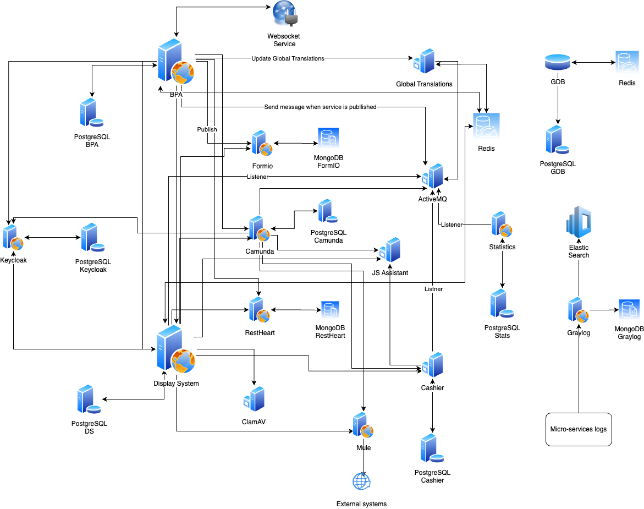

Detailed view
Let’s take an in-depth view on some of the most important components and their interactions.

BPA (Business Process Analyzer)
BPA is the system meant for administrator users to configure and generate services.
eRegistrations is a software allowing to create online services without any programming (no-code development platform).
An online service is a succession of online screens and actions through which:
- an applicant can fill a form, upload documents, pay and send his request (application file)
- one or more operators can review the file and approve or reject an application (processing)
- The applicant data is sent to an online registry
- A registration certificate is issued
Online services are visible on the “public site”, also called “user site” or “DS” (Display System)
They are created through an “administrative site”, also called “BPA” (Business Process Analyzer)
A deeper view into its internals:

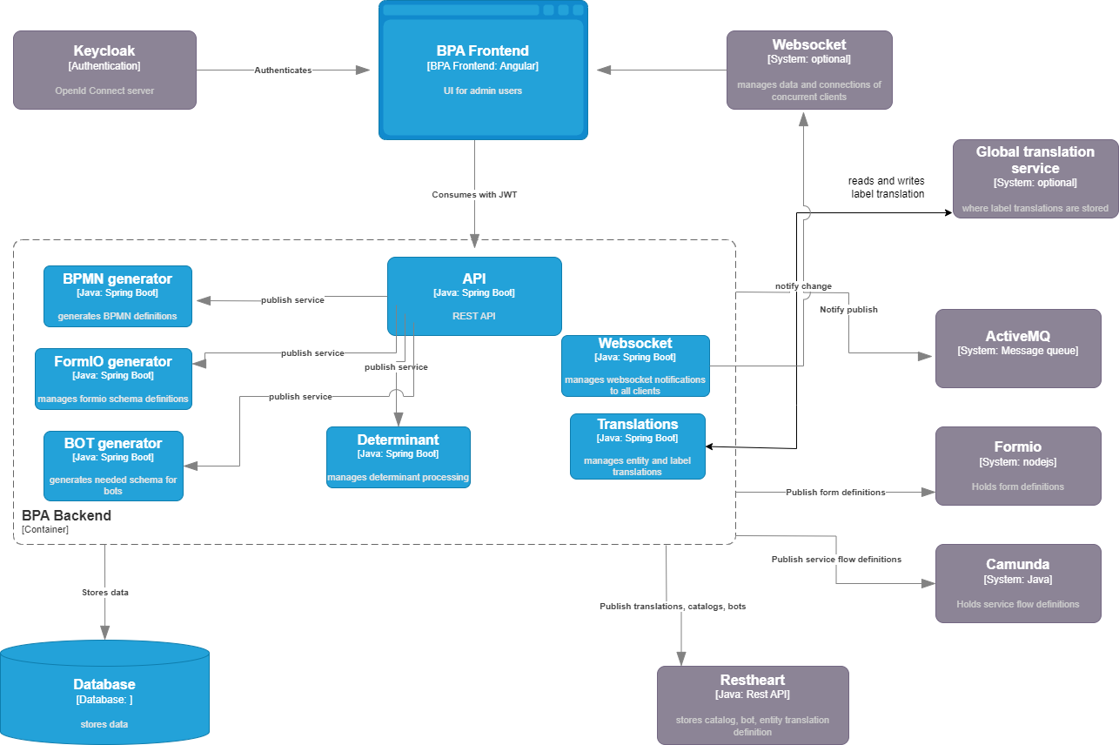

The BPA system is composed of 2 applications: BPA Backend - developed in Java, and BPA Frontend - a Single Page Application developed in Angular. Administrator users will access the Frontend application after authenticating and authorizing via Keycloak system. BPA Frontend consumes BPA backend REST API with every request being signed by the user JWT and verified for authorization.
Another component that comes into play while configuring the services is Websocket. This component is lightweight NodeJS one meant to track users working on the same page to avoid any concurrency issue.
The majority of operations done in BPA are mostly CRUD over the resources - please find the models in the annex.
The most important Domain Models of BPA are:
- User forms (sometimes referred to as Part A)
- Operator roles and their succession (sometimes referred to Part B)
- Catalogs (eg country list, regiones, cities) that can be reused among services
- Determinants (conditions defined in the system)
- BOTs (interactions with other systems defined in BPA)
- Translations

The most important process is publishing a service. Here BPA will process the data it has in its database, transform it into a format compliant with the different components and propagate all this configuration data to the correspondent component.

An important aspect to note is that the publishing of a service is versioned, meaning multiple versions of the same service are supported in the public portal and BPA publishing only appends service definitions.

Here is a closer look at the publish process:

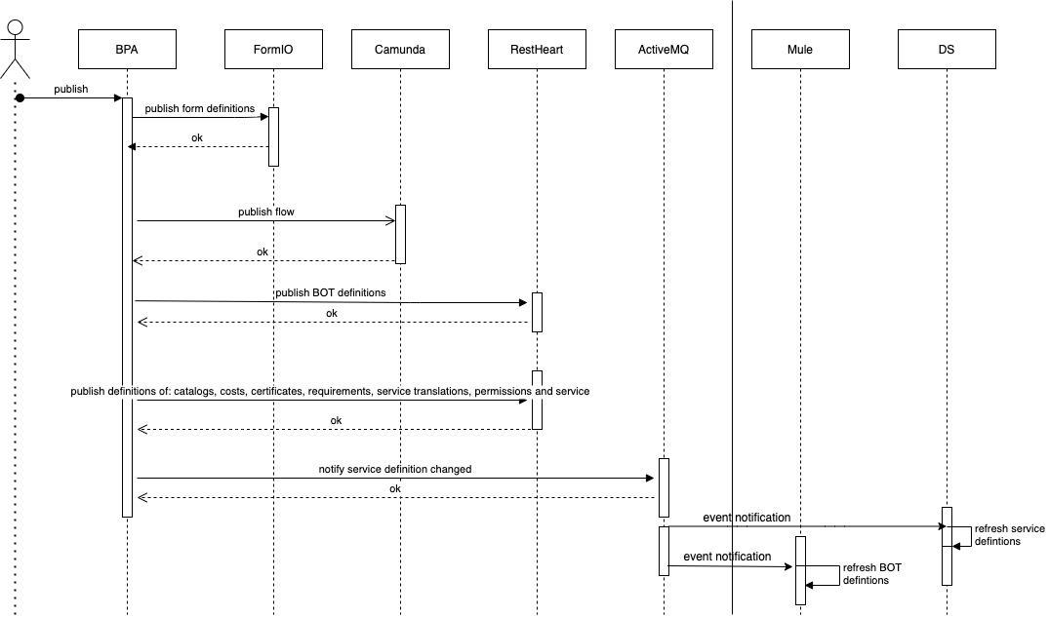

Once the user chooses to publish a service, BPA backend will start processing the form definitions of the system (adding needed conditions, catalog definitions, BOT triggers etc) and will store these form definitions in the Formio.io server, storing a reference to the IDs created for further use. The next step is that it takes the flow of part B roles, transforms it into BPMN format and sends it to the Camunda component for it to store. After this, BPA publishes the BOT definitions and other elements (catalogs, certificates translations etc) to RestHeart - they will be later read only at execution of a service.
Finally BPA sends a message to ActiveMQ that a new version of the service has been published. DS and Mule are subscribed to this message and they will now know to load new definitions.

DS (Display System)
The DS system is the public portal, the entry point for normal users of the system and operators in charge of processing user requests.

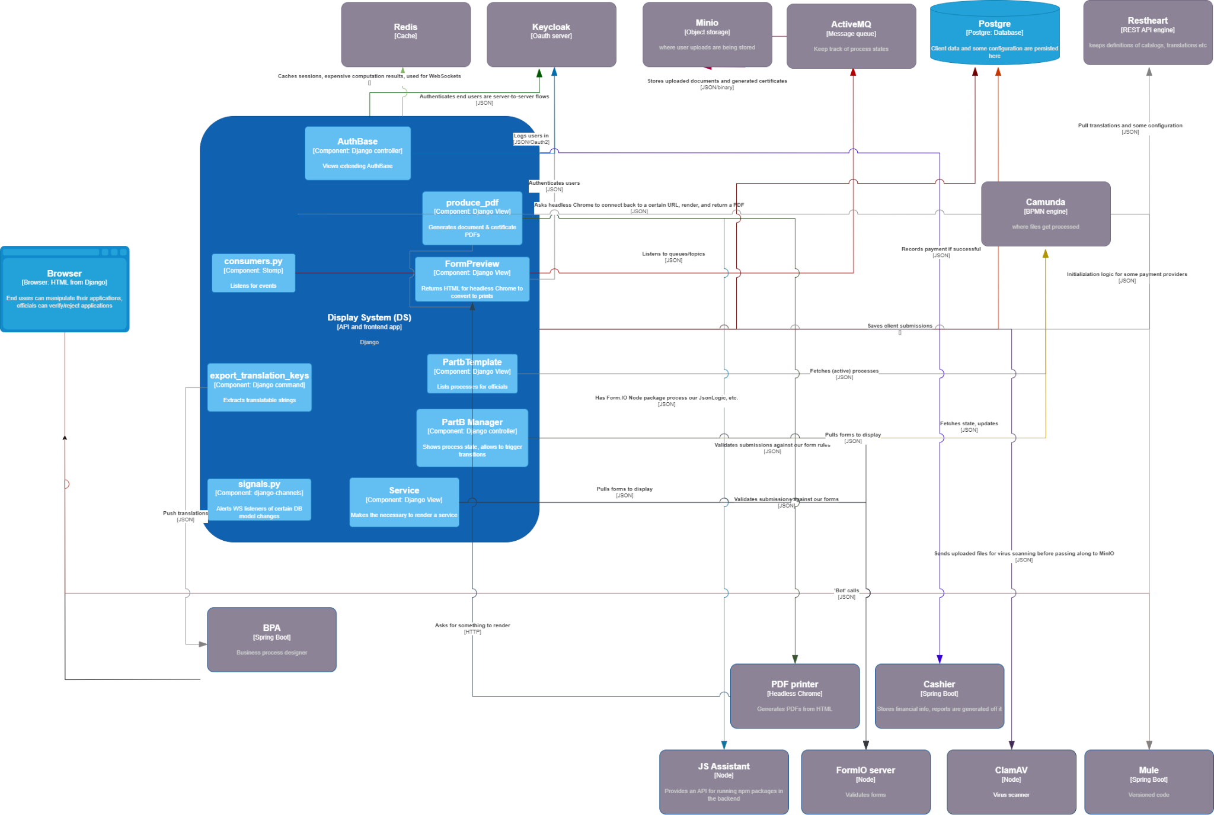
Users access DS via keycloak and mainly uses a cookie based session (JWT exchanged is some conditions) and serves Part A or Part B depending on the level of authorization of the user. It uses Redis as a cache solution for different elements (this ensures horizontal scalability).
The only moment where it communicates with BPA is at application startup when DS scans its labels and send them to BPA for the translation module. Otherwise, DS is completely independent and unaware of BPA existence.
The 3 most important parts of DS are:
- Access to user account - this is where the user sees the available services, their files and their status and any messages
- Service page - this is what is rendered when a user clicks on a service or on an existing file.
- Part B module: views meant for operators - list of files pending in specific roles and detailed view of files where operators can input their decision/data

Non critical communication of the system with other components is done in an async way, via ActiveMQ message subscription (eg: new service definition available, file status changes).

Please find in the annex the data models of DS.

The 2 most interesting processes in DS are submitting a file and processing a file. Here they are in more detail:

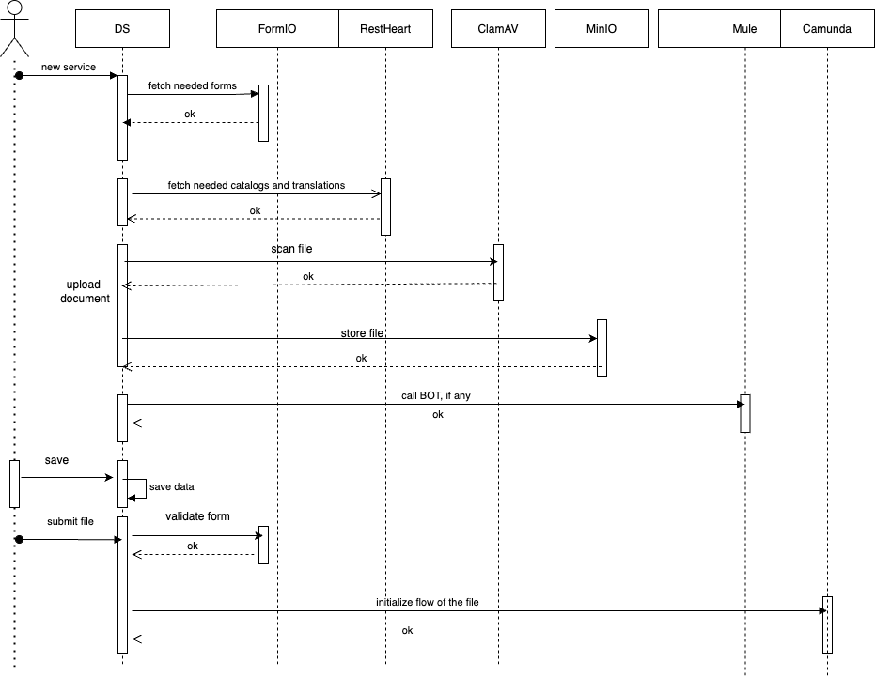
Once a user clicks on a service, DS will already have the reference of the form and will call the FormIO component for getting the form schema. Using the formio library, it will start rendering the form and call RestHeart for catalog and translation data.
In most cases, files need to be attached by users to the service, DS will firstly send these user uploads to ClamAV component for being scanned and if marked as safe, will store this using the Minio component - the object storage solution.
If any BOTs are being configured in the form, at the moment they are triggered, DS will call the necessary endpoint and interpret the result.
Finally, once the user clicks on the Submit file option, DS will firstly validate the data of the file against the formio schema server side by sending it to the Formio server and if this operation is successful, it will submit the data to Camunda. This is the moment that the file enters the Camunda flow, anything before that is considered a draft and only stored in the DS database.

Processing a file in part B can be summarized as follows:

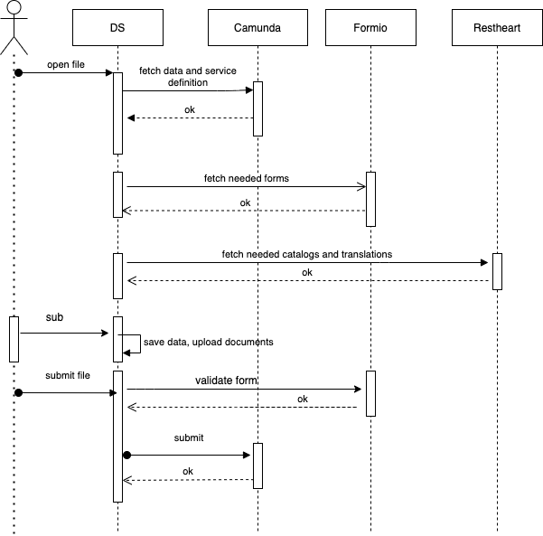
The operator opens a file stored in the flow, DS will load its definition from Camunda, which contains the precise form schema definition of the given version of the service. The needed version of any catalogs/translations is loaded in the form, as in part A.
The data of the file at the moment of the status change is saved in a versioned way in the Camunda database - an image of each of the moments of the file’s life cycle is available.

Otros recursos de utilidad
- Más acerca de la seguridad en el archivo de “Seguridad eRegistrations”

